Amazon translate is an amazing translation technology powered by AI and neural networks that can translate your documents and files automatically while maintaining its format. Your part is just to upload the document to the AWS storage and Amazon translate will translate the document and the best part is that the format of the document will not be destroyed.

Globalization has accelerated the demand for translation services. Traditional translation methods are expensive, manual and time consuming. Amazon translate is a neural network machine learning translation service that quickly and automatically translates language without destroying the format of the file. Since, Amazon translate uses neural networks, it is always improving. The more data Amazon translates gets, the better it performs. After all that is the basic foundation of machine learning.  The best part about Amazon translate is that it can translate within context and you can also customize the translation if you do not want to translate a specific word or phrase. It does beyond simple work level translation by understanding the context behind the words.

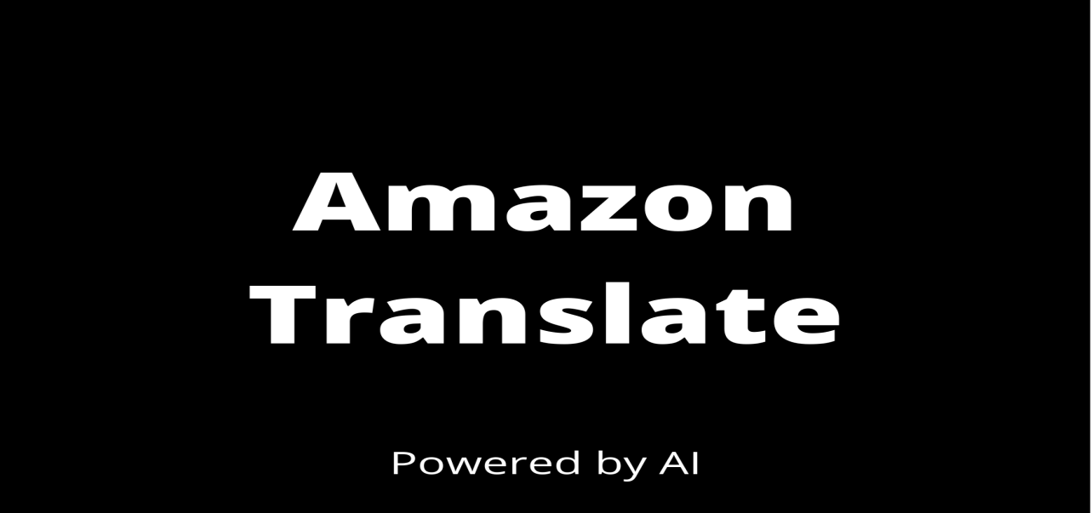

Providing information to customers, partners and investors is essential. Language barriers can slow and complicate this process. Language complications can hinder growth and innovation. When your company needs to provide translation files to your partners, you need a way to do this efficiently without manual processes. Amazon's batch translation feature is a great solution to it.

Suppose you have a 20 to 30 page report that you want to send to your Chinese clients. The report contains graphs and charts and other images. You can upload this report to AWS and Amazon Translate will translate this entire document automatically within minutes while maintaining the format. You can then download the translated document, proofread it and then send it to your clients after final touch up if needed. All this is absolutely free for up to 2 million characters per month which is more than enough for most small businesses or individuals. If you had to do the same thing by hiring a professional translator, it would be very expensive and time consuming for large reports which in the current corporate world is not efficient since everyone including your boss, managers, clients and investors wants everything ASAP.

If you are a Professional translator freelancer, you can use Amazon translate to do the heavy lifting for you by treating the documents and you can then proofread it and submit it which will reduce translation time from weeks and days to hours